A THREE-LEVEL LC-SWITCHING-BASED VOLTAGE BOOST NPC INVERTER
ABSTRACT
A single-stage high-voltage gain boost inverter is getting popularity in applications like solar photovoltaic, fuel cell, uninterruptible power system (UPS) systems, etc. Recently, single-stage voltage boost multilevel Z-source inverter (ZSI) and quasi-Z-source inverter (QZSI) have been proposed for dc–ac power conversion with improved power quality. Multilevel ZSI uses more number of high-power passive components in the intermediate network, which increase the system size and weight. Also, its input current is discontinuous in nature which is not desirable in some of the applications like fuel cell, UPS systems, hybrid electric vehicle, etc. In this paper, a continuous current input three-level LC-switching-based voltage boost neutral-pointclamped inverter is proposed, which uses comparatively less number of high-power passive components at the same time retains all the advantages of multilevel QZSI/ZSI. It is able to boost the input dc voltage and give required threelevel ac output voltage in a single stage. Steady-state analysis of the proposed inverter is discussed to formulate the relationship between the input dc voltage and three-level ac output voltage. A unipolar pulse width modulation technique devised for the proposed inverter to eliminate first center band harmonics is also presented. The proposed converter has been verified by simulation in MATLAB Simulink as well as performing experiment with the help of a laboratory prototype.

BLOCK DIAGRAM FOR PROPOSED SYSTEM
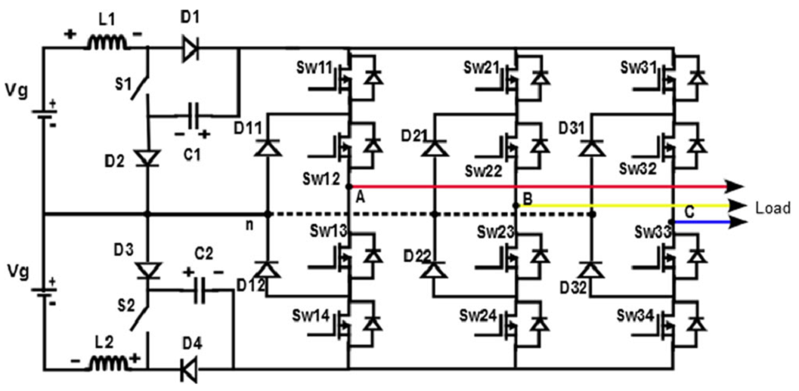
Fig. 1. Circuit diagram of a three-level LC-switching voltage boost NPC inverter
DESIGNG SOFTWARE AND TOOLS:
MAT LAB /SIMULATION Software and simu power systems tools are used. Mainly control system tools, power electronics and electrical elements tools are used.

